FIT2002 IT Project Management:

OEU Hybrid Campus Case Study

**Assignment Team:**

Timothy Correia-Paul

Neerav Mehta

Laurence Andrews

Rounak Agarwal

Contents Page

**Case 1 Task 1: Potential Projects Summary** **3**

**Case 1 Task 1.2: Memorandum** **6**

**Case 1 Task 2.1: Weighted Scoring Model** **7**

Weighted Scoring Model Justification 7

Supports Key Business Objectives Criteria & Calculation 7

ROI Calculation & Justification 8

NPV for potential projects 8

Table 5: NPV for project 1 8

Table 6: NPV for project 2 9

Table 7: NPV for project 3 9

Table 8: NPV for project 4 10

**Case 1 Task 3: Business Case** **11**

Table 9: Financial Analysis 13

**Case 1 Task 4: Project Charter** **14**

**Case 2 Task 1: Project Scope Statement** **16**

**Case 2 Task 2: Requirements Traceability Matrix** **18**

Table 10: Requirements Traceability Matrix 18

**Case 3 Task 1: Work Breakdown Structure (WBS)** **19**

Case 3 Task 2: SMART Milestones 22

Table 11: SMART Milestones 22

**Case 3 Task 3: Gantt Chart, Task Durations & Dependencies** **24**

**Case 3 Task 4: Network Diagram** **25**

**Case 4 Task 1: Cost Model** **26**

**Case 4 Task 2: Cost Allocation Baseline Model (Monthly)** **27**

**Case 4 Task 3: Cost Calculations** **29**

Earned Value Chart 30

MEMORANDUM 31

**Time Sheets:** **32**

Appendix: Meeting Minutes 37

Meeting 1: Introduction and Case Studies 37

Meeting 2: Case Study 1 38

Meeting 3: Case Study 2 39

Meeting 4: Case Study 3 40

Meeting 5: Case Study 4 41

Meeting 6: Submission Preparation 42

## Case 1 Task 1: Potential Projects Summary

*Table 1.1: Potential Projects Summary*

| **Project** | **Identify how each one supports business strategies** | **Assess the potential financial benefits and other benefits** | **Initial assessment of the value of each project** |
| --- | --- | --- | --- |
| Creating hybrid campuses | Goal 2) Hybrid campuses like this would lower the tuition fees, and is a unique way to study with a group for students and thus, can compete with the increasing supply of qualifications.  Goal 3) Since we are using the same material to teach as the other campuses, and all these campuses would be connected using video conferencing, the cooperation between campuses in terms of its product offerings would be improved.  Goal 4) As we are not creating new campuses from scratch and we are re-using the study material, the project is low-cost. | 3 year cost: $700,000  3 year returns:$1,450,000  Profit: $750,000 | * Its a low-cost project * It has ~100% ROI * Its risk free, as it’s not a permanent investment and, we can change our strategy in-case of a global pandemic. |
| Expand online | Goal 1) Expand the current customer base (of students).  This project supports this goal by allowing the OEU to tap into the online education market for sourcing new students.  Goal 4) Utilising technology for an improved product, lower costs and a subsequent competitive advantage.  “Although development will be slightly more expensive than creating face-to-face courses, the economies of  scale benefit will be much more prominent than other projects.”  “The company may obtain a competitive advantage in terms of cost, but will be competing with large MOOC  (Massive Open Online Course) service providers.”  Total Cost: 265k  Total Return: 500k  This project has a ~100% ROI by utilising technology for lower costs. | Total Cost: 265k  Total Return: 500k  Profit: 235k  This project has a ~87% ROI by utilising technology for lower costs. | * Expanding online is a safe, low risk investment. * Everything is expected to be online due to the covid context, so this may be mandatory to keep up with competition. * The projected revenues from this project are significantly lower than that of the other larger projects. * Total profits over the first 3 years will be 235k, which represents an 87% Return on Investment over the 3 year period. |
| New specialized, physical campuses | All of the 5 campuses will be customly designed for a small number of programmes and only top academics will be used at these campuses therefore the price of the tuition will be higher in comparison to the other campuses.  Video conferencing technology will be extensively used for guest speakers and collaborations between the students and industry thus providing an education product that is unique. | Initial Investment: $ 20 Million  Year 1 investment: $10 Million  Year 2 investment: $10 Million  Year 3 Investment: $10 Million  Total Investment: $50 Million  Year 1 Return: $10 Million  Following Year Return: $40 Million  3 Year Return: $90,000,000  3 Year Profit: $50,000,000 | * The project promises a return of around $10 Million and $40 Million the following years. * This project represents the highest risk, highest return option of the four proposed projects. * Total profits over the first 3 years will be $40,000,000, which represents an 80% Return on Investment over the 3 year period. |
| Upgrade current campuses | Accomodates 20% more students and provides a basis for easy marketing to expand customer base.  Improved network infrastructure and conferencing facilities to improve inter-campus cooperation.  Infrastructure and technology upgrades to provide an improved and competitive education product. | Total Cost: $5.4 Million  Year 1 Returns: $2 Million  Following Yearly Returns: $1 Million  Projected costs and returns show that the project will effectively cost $400k in the first year, $0 net cost in the second and third years. | The project will increase revenue by 60% which is significant however the ROI is fairly poor taking 4 years to pay off the cost. The project will address three goals quite well but fails to deliver a unique product. |

## Case 1 Task 1.2: Memorandum

Date: 15 November 2021

TO: Top Management

FROM: AMC Consulting

SUBJECT: New Project Proposals

Here’s a summary of all the project’s initial assessment to our understanding:

Project 1: Creating Hybrid Campuses

* its a low-cost project
* It has ~100% ROI
* Its risk free, as it’s not a permanent investment, and we can change our strategy in-case of a global pandemic.

Project 2: Expand Online

* Expanding online is a safe, low risk investment.
* Everything is expected to be online due to the covid context, so this may be mandatory to keep up with competition.
* The projected revenues from this project are significantly lower than that of the other larger projects.
* Total profits over the first 3 years will be 235k, which represents an 87% Return on Investment over the 3 year period.

Project 3: New specialized, physical campuses

* The project promises a return of around $10 Million and $40 Million the following years.
* This project represents the highest risk, highest return option of the four proposed projects.
* Total profits over the first 3 years will be $40,000,000, which represents an 80% Return on Investment over the 3 year period.

Project 4: Upgrade current campuses

* The project will increase revenue by 60% which is significant.
* However the ROI is fairly poor taking 4 years to pay off the cost.
* The project will address three goals quite well but fails to deliver a unique product.

After a careful review of all the four project proposals we would like to go ahead with Project 1 i.e. building Hybrid campuses because of an approximately 100% ROI, It is also easier to shut down this process in-case of an unfortunate event such as global pandemics, we would like to consider Project 2 into effect if such an event takes place.

## Case 1 Task 2.1: Weighted Scoring Model

*Table 2: Weighted Scoring Model*

| **Criteria** | **Weight** | **Project 1** | **Project 2** | **Project 3** | **Project 4** |
| --- | --- | --- | --- | --- | --- |
| Supports key business objectives / strategic goals | 25% | 42.5 | 67.5 | 60 | 80 |
| ROI (Relative) | 25% | 100 | 77.80648192 | 71.53593236 | 58.05542508 |
| Provides positive NPV | 25% | 50 | 25 | 100 | 75 |
| Low risk in meeting triple constraint | 25% | 80 | 93.33333333 | 46.66666667 | 66.66666667 |
| **Weighted Project Scores** | **100%** | **68.125** | **65.91** | **69.55** | **69.93** |

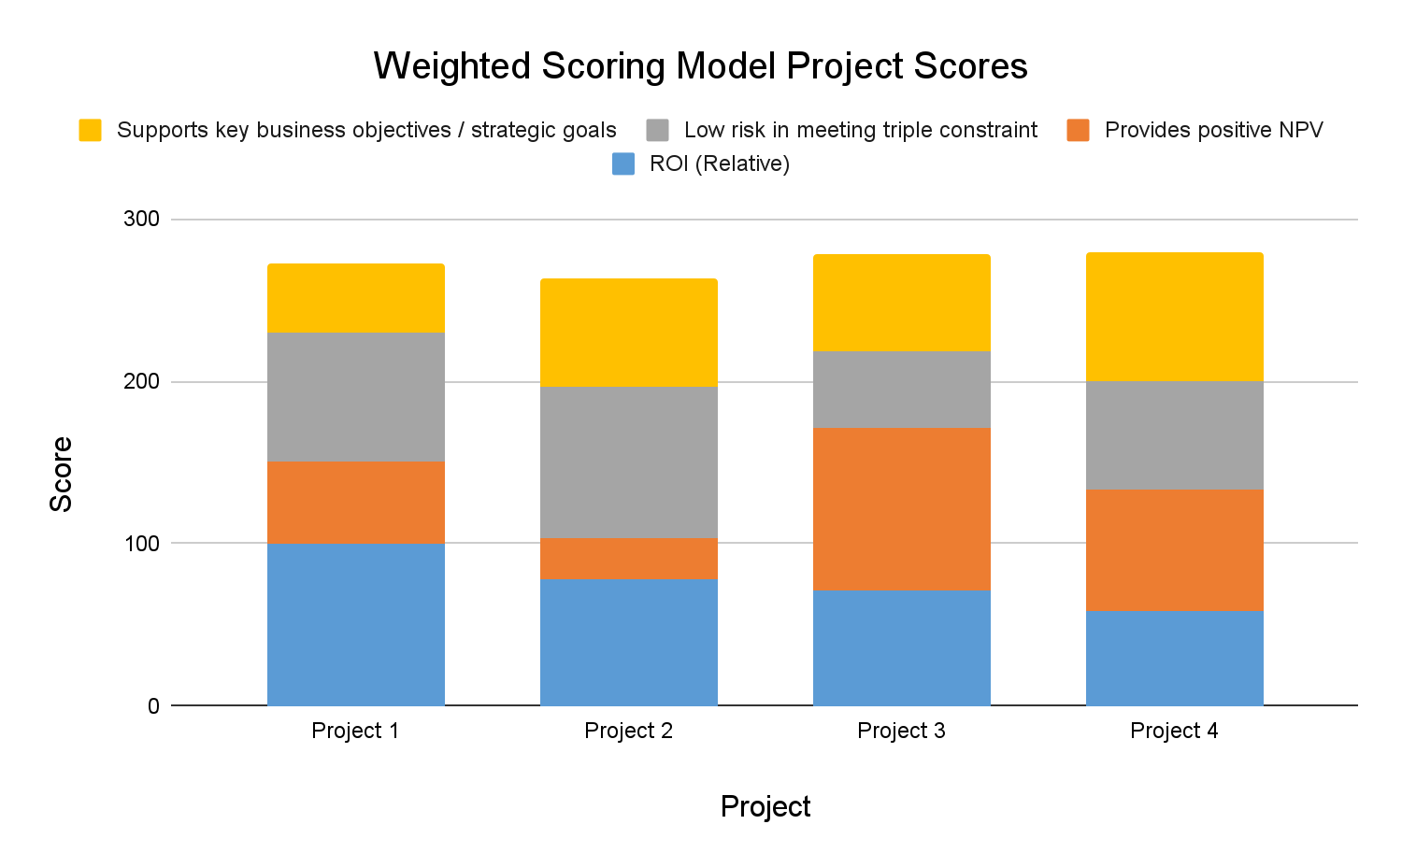

*Image 1: Weighted Scoring Model Scores, Stacked bar graph*

### Weighted Scoring Model Justification

* Regarding the weighting: use a balanced score card to look at the different perspectives.

*Since this is a university, we should use some criteria which weights some other non-financial criteria, as opposed to having 50% of the weighting being given to financial criteria.

* Provide a good reasonable justification for the criteria and weights chosen for the weighted scoring mode, and also the scoring itself

### Supports Key Business Objectives Criteria & Calculation

*Table 3: Key Business Objectives Criteria & Calculation*

| Criteria | **Project 1** | **Project 2** | **Project 3** | **Project 4** |
| --- | --- | --- | --- | --- |
| Objective #1 | 4 | 7 | 8 | 9 |
| Objective #2 | 6 | 4 | 8 | 5 |
| Objective #3 | 0 | 8 | 3 | 9 |
| Objective #4 | 7 | 8 | 5 | 9 |
| **Total Score** | **17** | **27** | **24** | **32** |

**Objective #1:** Expand the current customer base (of students).

**Objective #2:** Provide an education product that is unique and can compete with the increasing supply of qualifications

**Objective #3:** Improve cooperation between campuses in terms of its product offerings, sharing of resources and knowledge, and research.

**Objective #4:** Utilising technology for an improved product, lower costs and a subsequent competitive advantage

### ROI Calculation & Justification

*Table 4: ROI Calculation & Justification*

|  | Project 1 | Project 2 | Project 3 | Project 4 |
| --- | --- | --- | --- | --- |
| ROI | 85.16 | 66.26 | 60.92 | 49.44 |
| ROI (Relative) | 100 | 77.80648192 | 71.53593236 | 58.05542508 |

ROI(Relative) = ROI / Max(ROI), i.e. ROI / ROI of project 1.

### NPV for potential projects

### *Table 5: NPV for project 1*

| **Discount rate** | **9%** |  |  |  |  |  |
| --- | --- | --- | --- | --- | --- | --- |
|  |  |  |  |  |  |  |
| **Discount factor** | **1.00** | **0.92** | **0.84** | **0.77** |  |  |
|  | **Year** | | | | |  |
| **PROJECT 1** | **0** | **1** | **2** | **3** |  | **TOTAL** |
| Costs | **$200,000** | **$260,000** | **$120,000** | **$120,000** |  | **$700,000** |
| Discounted costs | **$200,000** | **$238,532** | **$101,002** | **$92,662** |  | **$632,196** |
|  |  |  |  |  |  |  |
| Benefits | **$0** | **$200,000** | **$500,000** | **$750,000** |  | **$1,450,000** |
| Discounted benefits | **$0** | **$183,486** | **$420,840** | **$579,138** |  | **$1,183,464** |
|  |  |  |  |  |  |  |
| Cash flow | **($200,000)** | **($60,000)** | **$380,000** | **$630,000** |  | **$750,000** |
| Discounted cash flow | **($200,000)** | **($55,046)** | **$319,838** | **$486,476** |  | **$551,268** |
| Cumulative disc cash flow |  |  |  |  | **$551,268** |  |
| **NPV** | **$551,268.12** |  |  |  |  |  |
| **ROI** | **87.20%** |  |  |  |  |  |

### *Table 6: NPV for project 2*

| **Discount rate** | **9%** |  |  |  |  |  |
| --- | --- | --- | --- | --- | --- | --- |
|  |  |  |  |  |  |  |
| **Discount factor** | **1.00** | **0.92** | **0.84** | **0.77** |  |  |
|  | **Year** | | | | |  |
| **PROJECT 2** | **0** | **1** | **2** | **3** |  | **TOTAL** |
| Costs | **$145,000** | **$40,000** | **$40,000** | **$40,000** |  | **$265,000** |
| Discounted costs | **$145,000** | **$36,697** | **$33,667** | **$30,887** |  | **$246,252** |
|  |  |  |  |  |  |  |
| Benefits | **$0** | **$100,000** | **$200,000** | **$200,000** |  | **$500,000** |
| Discounted benefits | **$0** | **$91,743** | **$168,336** | **$154,437** |  | **$414,516** |
|  |  |  |  |  |  |  |
| Cash flow | **($145,000)** | **$60,000** | **$160,000** | **$160,000** |  | **$235,000** |
| Discounted cash flow | **($145,000)** | **$55,046** | **$134,669** | **$123,549** |  | **$168,264** |
| Cumulative disc cash flow |  |  |  |  | **$168,264** |  |
| **NPV** | **$168,264.03** |  |  |  |  |  |
| **ROI** | **68.33%** |  |  |  |  |  |

### *Table 7: NPV for project 3*

| **Discount rate** | **9%** |  |  |  |  |  |
| --- | --- | --- | --- | --- | --- | --- |
|  |  |  |  |  |  |  |
| **Discount factor** | **1.00** | **0.92** | **0.84** | **0.77** |  |  |
|  | **Year** | | | | |  |
| **PROJECT 3** | **0** | **1** | **2** | **3** |  | **TOTAL** |
| Costs | **$20,000,000** | **$10,000,000** | **$10,000,000** | **$10,000,000** |  | **$50,000,000** |
| Discounted costs | **$20,000,000** | **$9,174,312** | **$8,416,800** | **$7,721,835** |  | **$45,312,947** |
|  |  |  |  |  |  |  |
| Benefits | **$0** | **$10,000,000** | **$40,000,000** | **$40,000,000** |  | **$90,000,000** |
| Discounted benefits | **$0** | **$9,174,312** | **$33,667,200** | **$30,887,339** |  | **$73,728,851** |
|  |  |  |  |  |  |  |
| Cash flow | **($20,000,000)** | **$0** | **$30,000,000** | **$30,000,000** |  | **$40,000,000** |
| Discounted cash flow | **($20,000,000)** | **$0** | **$25,250,400** | **$23,165,504** |  | **$28,415,904** |
| Cumulative disc cash flow |  |  |  |  | **$28,415,904** |  |
| **NPV** | **$28,415,904.20** |  |  |  |  |  |
| **ROI** | **62.71%** |  |  |  |  |  |

### *Table 8: NPV for project 4*

| **Discount rate** | **9%** |  |  |  |  |  |
| --- | --- | --- | --- | --- | --- | --- |
|  |  |  |  |  |  |  |
| **Discount factor** | **1.00** | **0.92** | **0.84** | **0.77** |  |  |
|  | **Year** | | | | |  |
| **PROJECT 4** | **0** | **1** | **2** | **3** |  | **TOTAL** |
| Costs | **$2,400,000** | **$1,000,000** | **$1,000,000** | **$1,000,000** |  | **$5,400,000** |
| Discounted costs | **$2,400,000** | **$917,431** | **$841,680** | **$772,183** |  | **$4,931,295** |
|  |  |  |  |  |  |  |
| Benefits | **$0** | **$2,000,000** | **$3,000,000** | **$4,000,000** |  | **$9,000,000** |
| Discounted benefits | **$0** | **$1,834,862** | **$2,525,040** | **$3,088,734** |  | **$7,448,636** |
|  |  |  |  |  |  |  |
| Cash flow | **($2,400,000)** | **$1,000,000** | **$2,000,000** | **$3,000,000** |  | **$3,600,000** |
| Discounted cash flow | **($2,400,000)** | **$917,431** | **$1,683,360** | **$2,316,550** |  | **$2,517,342** |
| Cumulative disc cash flow |  |  |  |  | **$2,517,342** |  |
| **NPV** | **$2,517,341.62** |  |  |  |  |  |
| **ROI** | **51.05%** |  |  |  |  |  |

## Case 1 Task 3: Business Case

| 1. **Introduction/ Background**   Open Education University (OEU) is a private university with 20 campuses across North America, Australia and Europe. While OEU is profitable, growth from campuses has slowed. OEU management has changed its strategy as well as its prominent strategic goals to address the issue and increase growth. In order to continue growth, OEU management has invited promising new project proposals to address these goals. |
| --- |
| **2.0 Business Objective**  OEU’s new prominent strategic goals are as follows:   * Expand the current customer base (of students). * Provide an education product that is unique and can compete with the increasing supply of qualifications. * Improve cooperation between campuses in terms of its product offerings, sharing of resources and knowledge, and research. * Utilising technology for an improved product, lower costs and a subsequent competitive advantage.   AMC Consulting’s project proposal of creating a hybrid campus model will address OEU’s strategic goals while increasing profitability. With low costs and high profitability, the hybrid campus project will boost OEU revenues. This project will expand the customer base, provide a unique education product, as well as utilise technology for an improved product, lower costs and competitive advantage. OEU is focused on projects which address its strategic goals; this project meets those criteria. |
| **3.0 Current Situation and Problem/Opportunity Statement**  OEU currently has 20 campuses across North America, Australia and Europe, with over 9,000 full time employees and another 3,500 freelance workers. While still profitable, OEU’s growth has slowed. OEU’s new strategic goals for improving growth can be met by the hybrid campus project. Hybrid campuses are expected to lower tuition fees, thereby addressing strategic goals relating to growth in the customer base and improving the university’s competitiveness. As the project does not involve the physical construction of new campuses, the risk of missing the project’s triple constraint is low. |
| **4.0 Critical Assumption and Constraints**  The proposed hybrid campus project must be a valuable asset for OEU. Current consultants and clients must actively support the project, and it must pay for itself within three years by reducing internal operating costs and generating new business. The Project Management Office manager must lead the effort, and the project team must include participants from several parts of the company, as well as from current client organizations. The new system must run on existing hardware and software, and it should require minimal technical support. It must be easily accessible by consultants and clients and be secure from unauthorized users. |
| **5.0 Analysis of Option and Recommendation**  There are three options for addressing this opportunity:   1. Do nothing. The business is doing well, and we can continue to operate without this new project. 2. Consider a different project to address OEU’s strategic goals. 3. Implement this new hybrid campus model to address OEU’s strategic goals.   Based on discussions with stakeholders, we believe that option 3 is the best option. |
| **6.0 Preliminary Project Requirements**  The main features of the hybrid campuses include the following:   1. Each study centre will be equipped with a large video screen, a camera and microphone. The video conferencing class will be two-way, where the lecturer can see all students in all classes while lecturing. Students will also be able to ask questions during a lecture. 2. Each study centre will be established in buildings belonging to local communities (e.g. church halls or recreation centres). This will reduce the cost paid for rent, but will also provide an additional income stream to these (usually not-for-profit) community initiatives. A study centre will accommodate up to 50 students per class. 3. Up to 10 study centres can be linked to a specific lecture. This will enable some economy of scale (up to 500 students per lecture). Due to the interactivity of the class, the quality of learning is expected to be higher than that of completely online courses. 4. The hybrid campuses are expected to lower the tuition fees, which is expected to make the university more competitive. 5. Although lectures are delivered via video conferencing, students are not isolated at home. They attend a class with fellow students, even if the lecturer is not physically present in such a class. A centre manager will be responsible for discipline and administrative duties during lectures. 6. Students submit all assignments online, but will write physical tests and exams at the respective study centres. These will be scanned and sent to lecturers for marking. 7. This project will not involve any additional costs for developing course material, since the material used at other campuses should be adequate. |
| **7.0 Budget Estimate and Financial Analysis**  The estimated project costs are:   * Establishing a studio (assuming that no building costs are required): $400,000 * Equipping 10 study centres at $30,000 each: $300,000 * Total cost: $700,000   Assume the following cash outflow:   * Beginning of first year: $200,000 * End of first year: $260,000 * End of second and third year: $120,000 each   The estimated financial benefit from the project: $200,000 end of first year, $500,000 end of second year and $750,000 at the end of third year. Exhibit A summarizes the projected costs and benefits and shows the estimated net present value (NPV), return on investment (ROI), and year in which payback occurs. It also lists assumptions made in performing this preliminary financial analysis. All of the financial estimates are very encouraging. The estimated payback is within one year, as requested by the sponsor. The NPV is $551,268, and the discounted ROI based on a three-year system life is excellent at 87.20% percent. |
| **8.0 Schedule Estimate**  The sponsor would like to see the project completed within one year. We also assume that the new system will have a useful life of at least three years. |
| **9.0 Potential Risks**  This project carries several risks. The foremost risk is a lack of interest in the new hybrid campus model by our current and future students. Students’ and customers’ inputs are crucial for addressing their needs and realizing the potential benefits for the hybrid model. There are some technical risks in choosing the type of software used to search the system, check security, process payments, and so on, but the features of this system all use proven technologies. The main business risk is investing the time and money into this project and not realizing the projected benefits. |
| **10.0 Exhibits**  Exhibit A: Financial Analysis *Table 9: Financial Analysis*  | **Discount rate** | **9%** |  |  |  |  |  | | --- | --- | --- | --- | --- | --- | --- | |  |  |  |  |  |  |  | | **Discount factor** | **1.00** | **0.92** | **0.84** | **0.77** |  |  | |  | **Year** | | | | |  | | **PROJECT A** | **0** | **1** | **2** | **3** |  | **TOTAL** | | Costs | **$200,000** | **$260,000** | **$120,000** | **$120,000** |  | **$700,000** | | Discounted costs | **$200,000** | **$238,532** | **$101,002** | **$92,662** |  | **$632,196** | |  |  |  |  |  |  |  | | Benefits | **$0** | **$200,000** | **$500,000** | **$750,000** |  | **$1,450,000** | | Discounted benefits | **$0** | **$183,486** | **$420,840** | **$579,138** |  | **$1,183,464** | |  |  |  |  |  |  |  | | Cash flow | **($200,000)** | **($60,000)** | **$380,000** | **$630,000** |  | **$750,000** | | Discounted cash flow | **($200,000)** | **($55,046)** | **$319,838** | **$486,476** |  | **$551,268** | | Cumulative disc cash flow |  |  |  |  | **$551,268** |  | | **NPV** | **$551,268.12** |  |  |  |  |  | | **ROI** | **87.20%** |  |  |  |  |  | |

## Case 1 Task 4: Project Charter

**Project Title**: Creating hybrid campuses

**Project Start Date:** 10 December 2021 **Projected Finish Date:** 15 October 2024

**Budget Information:**

Open Education University is funding this project. The initial budget of $700,000 would be used to set up the remote study centres and studios. The cost to equip each study centre is $30,000 and a total of 10 study centres are meant to be set up. The cost to establish the studio is $400,000.

**Project Manager:** Neerav Mehta, 04xxxxxxxx, nmeh@oeu.com

**Project Objectives:**

The objective of this project is to:

1. increase the customer base,
2. providing unique teaching solutions, even during uncertain times(COVID Pandemic),
3. providing improved cooperation between all campuses, and
4. utilising technology for an improved and unique education offering

**Main Project Success Criteria:**

As the stakeholders participating in the project are different, they have different expectations, the following are listed below:

1. University Management:

* The university management team would like to maximize profits.
* Complete the project on time
* advertise the unique project to the target audience i.e. the students

1. Professors:

* Delay and error free connection
* Ease of software and studio use

1. Students:

* Delay and error free connections
* ease of accessibility to study centre

**Approach:**

1. Research local community buildings for viability, and IT infrastructure appropriate for the building
2. Installation of the IT infrastructure in the respective buildings
3. Develop the studio’s and study centre’s physical infrastructure.
4. Integrate third party software for better teaching and learning accessibility.
5. Advertise the project to the target audience i.e, the students.

**Roles and Responsibilities**

| **Role** | **Name** | **Organization/**  **Position** | **Contact Information** |
| --- | --- | --- | --- |
| **Project Manager** | **Neerav Mehta** | **Manager** | **nmeh@oeu.com** |
| **Team Member** | **Rounak Agarwal** | **Programmer** | **raga0003@monash.edu** |
| **Team Member** | **Laurence Andrews** | **Insights analyst** | **laurence1021@gmail.com** |
| **Team Member** | **Timothy Correia-Paul** | **IT** | **tcor0005@student.monash.edu** |

**Sign-off:**

Neerav Mehta

Rounak Agarwal

Laurence Andrews

Timothy Correia-Paul

## Case 2 Task 1: Project Scope Statement

| **Project Title: Creating Hybrid Campuses**  **Date:** November 17, 2021 **Prepared by: AMC Consulting** |
| --- |
| **Project Purpose and Justification:**  The main objective of the project is to expand the student base of the Open Education University (OEU), and to give its existing student base a unique and active learning experience unlike the other universities in the education market. This will also enhance the cooperation between all these campuses and allow us to use the existing technology to improve our current education product.The Hybrid Campus project justifies the prominent goals of the OEU and also guarantees a 100% ROI in the very first year making it a sustainable project. The project is not permanent and can be shut down without much losses in-case of global pandemics or lockdowns. The invested technology can be used in other projects as well. |
| **Product Characteristics and Requirements:**  After the completion of the project we should be able to set up 10 such full functioning hybrid campuses, along with one studio for the lecturer.   1. Setting up space for 50 students in each campus 2. Providing a reliable wifi network along with a big enough monitor positioned so that 50 students can view it 3. Equipment for each campus such as the few cameras to cover the entire student body in the campus for the lecturer, scanners and 1-2 administor for each campus. 4. Studios must contain a well function PC for the lecturer, along with a reliable and powerful wi-fi network. 5. Teaching tools such as a well functioning microphone, headset, a graphic drawing tablet and a green screen to make it easier for the lecturer to teach on the fast paced online environment also covers the project scope 6. Setting up the software for the Video Conferencing. |
| **Boundaries**  The project scope doesn’t include the furniture set up for all the students as the host location such as church or function hall needs to account for it.  The lecturers must get themselves acquainted with this dynamic style of teaching. |
| **Summary of Project Deliverables**  Project deliverables are the products or outputs that project is intended to produce. Deliverables may also include various reports or documentation.    1. **Project management-related deliverables:**  E.g.: business case, charter, team contract, scope statement, and any other documents required to manage the project.  1.1. Business Case Statement  1.2. Business Charter  1.3. Team Contract  1.4. Project Scope Statement  1.5. Requirement Traceability Matrix      2. **Product-related deliverables:**  E.g.: design documents, software code, hardware, etc.  1.1. Software Code for Video Conferencing  1.2. All the hardware including cameras, microphones, monitors and headphones  1.3. Design Documents |

## Case 2 Task 2: Requirements Traceability Matrix

### *Table 10: Requirements Traceability Matrix*

| **REQUIREMENTS TRACEABILITY MATRIX** | | | | | |
| --- | --- | --- | --- | --- | --- |
| **Project Name:** | Hybrid campus |  |  |  |  |
| **Project Manager Name:** | Neerav Mehta |  |  |  |  |
| **Project Description:** | Requirements for the Hybrid campus | | | | |
| ***ID*** | ***Requirements (Functional or Non-Functional)*** | ***Assumption(s)***  ***and/or Customer Need(s)*** | ***Category*** | ***Source*** | **Status** |
| 001 | Local accreditation criteria | There is a physical library at the study centre | Quality requirement | OEU Stakeholder | Not Started |
| 002 | IT Compatibility issues should be addressed | IT and internet infrastructure differ across countries | Performance requirement | OEU Stakeholder | Not Started |
| 003 | Video Conferencing system should be easy to use | Centre managers may not have a lot of experience in technology. | Service requirement | OEU Stakeholder | Not Started |
| 004 | Training should be provided for these video conferencing tools | Centre managers may not have a lot of experience in technology. | Training requirement | OEU Stakeholder | Not Started |
| 005 | Lecturers should be able to see every classroom dialled into the lecture | It is mainly so that the lecturers can keep an eye on what each class is doing | Quality requirement | OEU Stakeholder | Not Started |
| 006 | Student Learning management system should be designed |  | Service requirement | OEU Stakeholder | Not Started |
| 007 | Training should be provided for these student learning management systems | Since the application of this system may be different for distant lecturers and students. | Training requirement | OEU Stakeholder | Not Started |
| 008 | Student learning management system should be used for all in-semester assessments. | So that it minimizes the work for lecturers without sacrificing the quality of assessments | Quality requirement | OEU Stakeholder | Not Started |
| 009 | An assessment policy and procedures should be developed | To counter students need special consideration and also keep track of integrity issues. | Quality requirement | OEU Stakeholder | Not Started |

## Case 3 Task 1: Work Breakdown Structure (WBS)

**1 Initiation**

**1.1 Initiation of analysis into the potential projects**

1.1.2 Initial summary of the 4 potential projects

1.1.3 Weighted Scoring Model of the 4 potential projects

**1.2 Initiation of Hybrid Campus Project**

1.2.1 Assign team member roles

1.2.2 Produce the business case

1.2.3 Produce the project charter

**2 Planning**

**2.1 Project Scope Management**

**2.1.1 Plan scope management**

2.1.1.1 Scope management plan

2.1.1.2 Requirements management plan

**2.1.2 Collect requirements**

2.1.2.1 Requirements documentation

2.1.2.2 Requirements traceability matrix

**2.1.3 Define scope**

2.1.3.1 Project scope statement

2.1.3.2 Project documents updates

**2.1.4 Create WBS**

2.1.4.1 Scope baseline

2.1.4.2 Project documents updates

2.2 Project Schedule Management

**2.2 Develop a schedule management plan**

2.5.1 Define activities

2.5.2 Sequence activities

2.5.3 Estimate activity durations

2.5.4 Develop schedule based on the listed activities

**2.6 Develop a project cost management plan**

**2.6.1 Estimate Costs**

2.6.1.2 Cost Model

2.6.1.3 Cost baseline

2.6.1.1 EVM (Earned Value Management)

2.6.2 Produce the budget

**3 Execution**

**3.1 Hybrid Campus Concept**

3.1.1 Evaluate current systems

**3.1.2 Define Requirements**

3.1.2.1 Central hub & studio requirements

3.1.2.2 Study centre requirements

3.1.2.3 Software system requirements

3.1.2.4 Hardware requirements

3.1.2.5 Server & admin requirements

**3.1.3 Define specific functionality**

3.1.3.1 Central hub & studio functionality

3.1.3.2 Study centre functionality

3.1.3.3 Software system functionality

3.1.3.4 Hardware functionality

3.1.3.5 Server & admin functionality

3.1.4 Define risks and risk management approach

3.1.5 Develop project plan

3.1.6 Brief hybrid campus project team

**3.2 Hybrid Campus Design**

3.2.1 Building Design

3.2.2 IT infrastructure design

**3.3 Year 1 Hybrid Campus Development**

**3.3.1 Acquisition for study studios**

3.3.1.1 Survey community for buildings suitable as study centres

3.3.1.2 Identify the 2 most suitable buildings for study centres

3.3.1.3 Negotiate contracts for study centres

3.3.2 Central hub & studio development

3.3.3 Study centre development

3.3.4 IT infrastructure development

3.3.5 Marketing & Advertising

**3.4 Year 2 Hybrid Campus Development**

**3.3.1 Acquisition for study studios**

3.3.1.1 Survey community for buildings suitable as study centres

3.3.1.2 Identify the 4 most suitable buildings for study centres

3.3.1.3 Negotiate contracts for study centres

3.3.2 Central hub & studio development

3.3.3 Study centre development

3.3.4 IT infrastructure development

**3.5 Year 3 Hybrid Campus Development**

**3.3.1 Acquisition for study studios**

3.3.1.1 Survey community for buildings suitable as study centres

3.3.1.2 Identify the 4 most suitable buildings for study centres

3.3.1.3 Negotiate contracts for study centres

3.3.2 Central hub & studio development

3.3.3 Study centre development

3.3.4 IT infrastructure development

**3.6 Hybrid Campus Roll Out**

3.4.1 First Semester

3.4.2 First Semester Review

**3.7 Hybrid Campus Support and Maintenance**

3.5.1 Support team development

3.5.2 Maintenance team development

**1.4 Monitoring & Controlling**

**1.4.1 Validate Scope**

1.4.1.1 Accepted Deliverables

1.4.1.2 Change requests

1.4.1.3 Work performance information

1.4.1.4 Project documents updates

**1.4.2 Control Scope**

1.4.2.1 Work performance information

1.4.2.2 Change requests

1.4.2.3 Project management plan updates

1.4.2.4 Project documents updates

1.4.2.5 Organizational process assets updates

1.4.3 Control Schedule

1.4.4 Control Cost

**1.5 Closing**

**1.5.1 Assess the project with stakeholders**

1.5.1.1 Present the final product (deliverables) and sign off with the stakeholders

1.5.2 Produce the final documents

1.5.3 Update organisational process

## Case 3 Task 2: SMART Milestones

### *Table 11: SMART Milestones*

| **Milestone** | **Specific** | **Measurable** | **Assignable** | **Realistic** | **Time-Frame** |
| --- | --- | --- | --- | --- | --- |
| Project evaluated as feasible by management team | Specific as it relates to the completion of a single process | Measured via feasibility being approved | Project manager | Realistic as it is a short, independent task | 7 days |
| WBS developed and outlines scope and key project requirements | Specific as it relates to the completion of a single process | Measured by WBS being signed off | Project manager | Realistic as it is a short, independent task | 7 days |
| Schedule management plan completed | Specific as it relates to the completion of a single process | Measured by SMP being signed off | Project manager | Realistic as it is a short, independent task | 7 days |
| Cost estimation and management plan completed | Specific as it relates to the completion of a single process | Measured by being signed off | Project manager | Realistic as it is a short, independent task | 7 days |
| Project management plan accepted | Specific as it relates to the completion of a single process | Measured by plan being accepted | Project manager | Realistic as it is a short, independent task | 7 days |
| Studio and two study centre locations scouted, accepted by management team and contracted for long term rental | Specific as it refers to the quality of the locations and the validity of the rental contracts | Measured by rental contracts being completed | Daniel Ross | Realistic as ample time and resources are provided | 2 months |
| Studio and two study centres prepared for classes including all audio/visual equipment installed and ready for use | Specific as the sub-tasks culminate in a single specific milestone of being ready for use | Measured by facilities being evaluated as ready for use | Stephanie Gerald | Realistic as ample time and resources are provided | 8 months |
| Second year study centre locations scouted, accepted by management team and contracted for long term rental | Specific as it refers to the quality of the locations and the validity of the rental contracts | Measured by rental contracts being completed | Daniel Ross | Realistic as ample time and resources are provided | 1 month |
| Second year study centres prepared for classes including all audio/visual equipment installed and ready for use | Specific as the sub-tasks culminate in a single specific milestone of being ready for use | Measured by facilities being evaluated as ready for use | Stephanie Gerald | Realistic as ample time and resources are provided | 8 months |
| Third year study  centre locations scouted, accepted by management team and contracted for long term rental | Specific as it refers to the quality of the locations and the validity of the rental contracts | Measured by rental contracts being completed | Daniel Ross | Realistic as ample time and resources are provided | 1 month |
| Third year study centres prepared for classes including all audio/visual equipment installed and ready for use | Specific as the sub-tasks culminate in a single specific milestone of being ready for use | Measured by facilities being evaluated as ready for use | Stephanie Gerald | Realistic as ample time and resources are provided | 8 months |

## Case 3 Task 3: Gantt Chart, Task Durations & Dependencies

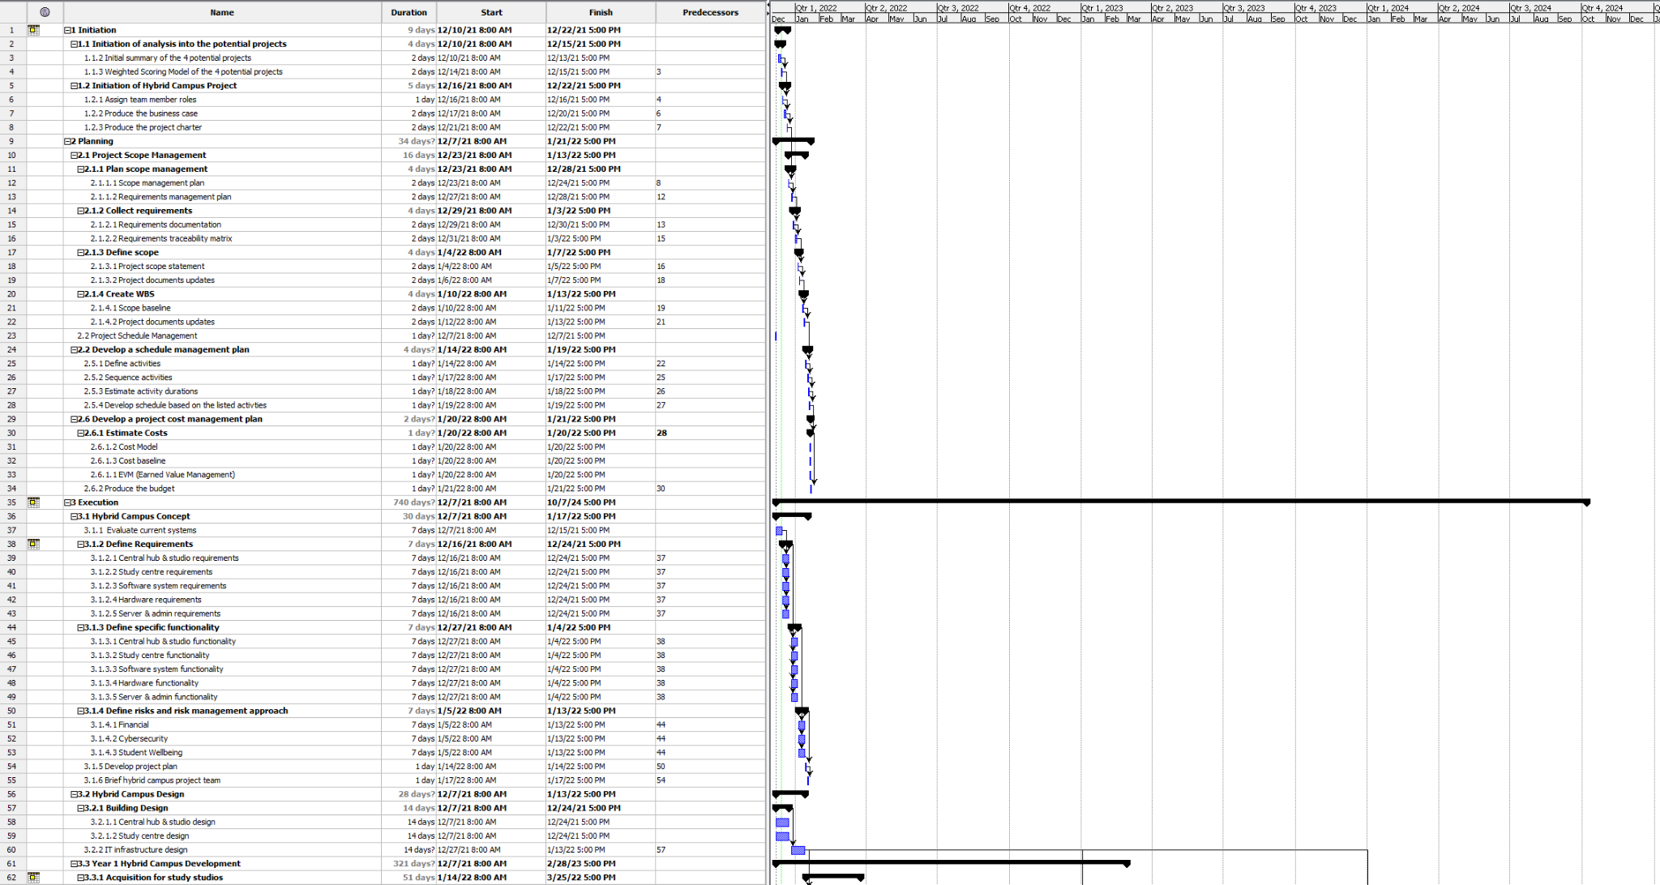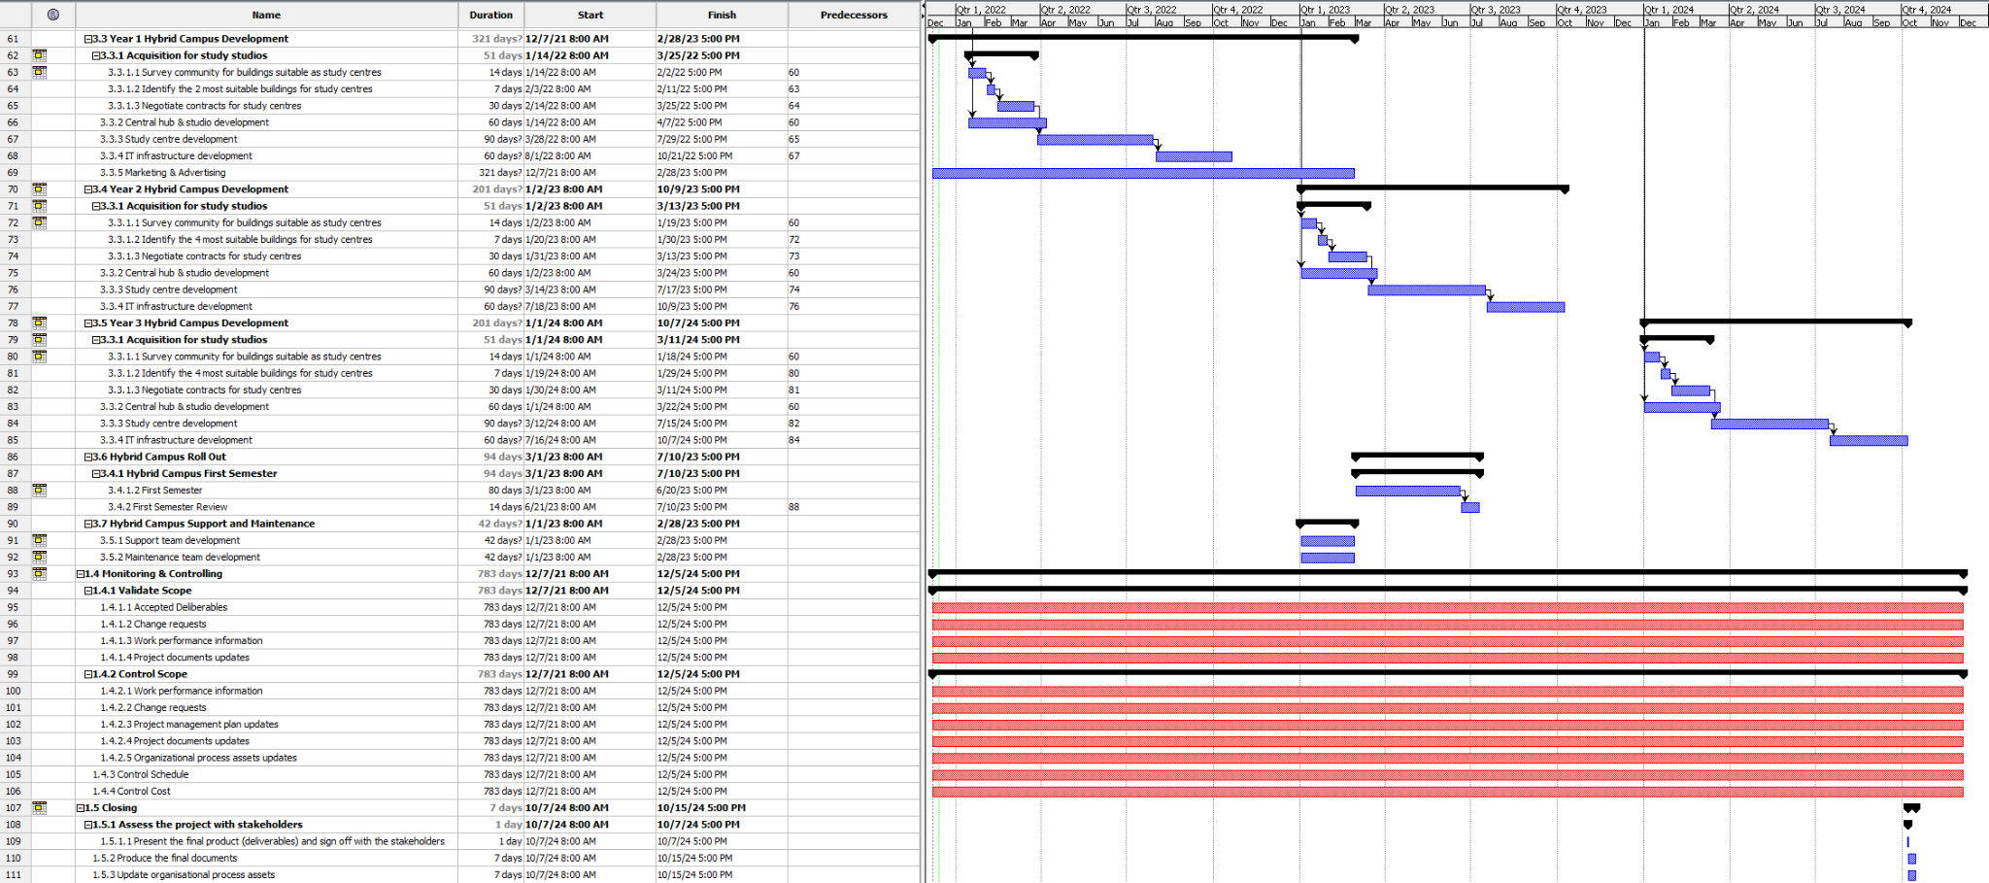

The task duration estimates have been made in conjunction with the PERT estimation technique, of course following the formula (O + 4M +P) / 6. Our optimistic estimate was made in the context of ideal but realistic circumstances, for example an optimistic estimate for scouting potential study center locations would see team members finding a good location every second day while a pessimistic estimate would be one per week in a situation such as COVID.

We have made the assumption that as per Case 2, the initial hub and studios will be located at the companies HQ, therefore a location does not need to be scouted. We have many initial administrative deliverables being completed simultaneously as they often involve different types of research and stakeholder discussion. We have also estimated second and third year construction times to be around 6 months’ worth of business days for the study centers; this assumes that the company doesn’t want construction to take place all year round.

## Case 3 Task 4: Network Diagram

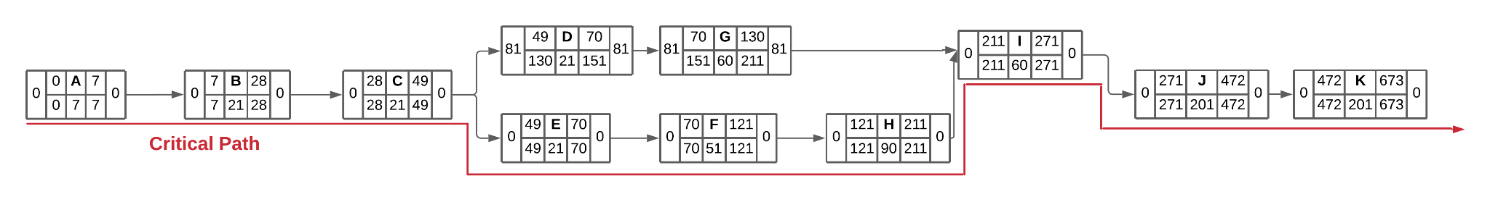

| # | Activity | Dependencies | Duration |
| --- | --- | --- | --- |
| A | Evaluate current systems |  | 7 |
| B | Building requirements investigated | A | 21 |
| C | IT requirements investigated | B | 21 |
| D | Central studio design | C | 21 |
| E | Study centre design | C | 21 |
| F | Study centre locations selected | E | 51 |
| G | Central hub IT infrastructure installed | D | 60 |
| H | Study studios IT infrastructure installed | E | 90 |
| I | Hub-Studio IT link connected | G, H | 60 |
| K | Four additional study centres selected, infrastructure installed and connected to hub | I | 201 |
| K | Four additional study centres selected, infrastructure installed and connected to hub | J | 201 |

## Case 4 Task 1: Cost Model

**Task 1**

| **WBS Items** | **cost in 12-month period** | **% of time on project** | **Subtotal** | **Section Totals** |
| --- | --- | --- | --- | --- |
| **1. PM** |  |  |  | $108,000 |
| Project Manager | $108,000 | 100% | $108,000 |  |
| **2. Networking** |  |  |  | $105,700 |
| Network specialist | $96,000 | 70% | $67,200 |  |
| Video Conferencing specialist | $50,000 | 65% | $32,500 |  |
| Developers/Programmers | $60,000 | 10% | $6,000 |  |
| **3. Technological Infrastructure** |  |  |  | $1,029,000 |
| Property | $729,000.00 |  | $729,000 |  |
| Tech Equipments |  |  | $300,000 |  |
| **4. Education Material** |  |  |  | $53,500 |
| Educational expert | $70,000 | 45% | $31,500 |  |
| LMS expert | $55,000 | 40% | $22,000 |  |
| **5. Advertisement** |  |  |  | $52,050 |
| Business and marketing expert | $72,000 | 25% | $18,000 |  |
| Systems analyst | $96,000 | 25% | $24,000 |  |
| Content editors | $67,000 | 15% | $10,050 |  |
| **6. Testing (10% of item 2)** |  |  |  | $10,570 |
| **7. Reserves (15% of total estimate)** |  |  |  | $105,000 |
| **Total Project Estimate** |  |  |  | $1,463,820 |

* **PM**
  + Project Manager
* **Networking**
  + Network specialist
  + Video Conferencing specialist
  + Developers/Programmers
* **Technological Infrastructure**
  + Tech Equipments
* **Education material** 
  + Educational expert
  + LMS expert
* **Advertisement**
  + Business and marketing expert
  + Systems analyst
  + Content editors

## Case 4 Task 2: Cost Allocation Baseline Model (Monthly)

| **WBS Items** | **1** | **2** | **3** | **4** | **5** | **6** | **7** | **8** | **9** | **10** | **11** | **12** | **Section Totals** |
| --- | --- | --- | --- | --- | --- | --- | --- | --- | --- | --- | --- | --- | --- |
| **1. PM** |  |  |  |  |  |  |  |  |  |  |  |  | $108,000 |
| Project Manager | $9,000 | $9,000 | $9,000 | $9,000 | $9,000 | $9,000 | $9,000 | $9,000 | $9,000 | $9,000 | $9,000 | $9,000 |  |
| **2. Networking** |  |  |  |  |  |  |  |  |  |  |  |  | $105,700 |
| Network specialist |  | $4,800 | $7,200 | $7,200 | $7,200 | $7,200 | $7,200 | $7,200 | $7,200 | $7,200 | $4,800 |  |  |
| Video Conferencing specialist |  |  |  |  | $4,000 | $4,000 | $4,000 | $4,000 | $4,150 | $4,150 | $4,150 | $4,150 |  |
| Developers/Programmers |  |  |  |  |  |  |  |  |  | $2,000 | $4,000 |  |  |
| **3. Infrastructure** |  |  |  |  |  |  |  |  |  |  |  |  | $1,029,000 |
| Property | $60,750 | $60,750 | $60,750 | $60,750 | $60,750 | $60,750 | $60,750 | $60,750 | $60,750 | $60,750 | $60,750 | $60,750 |  |
| Tech Equipments |  |  | $100,000 | $200,000 |  |  |  |  |  |  |  |  |  |
| **4. Education Material** |  |  |  |  |  |  |  |  |  |  |  |  | $53,500 |
| Educational expert |  |  |  |  |  |  | $2,333 | $5,833 | $5,833 | $5,833 | $5,833 | $5,833 |  |
| LMS expert |  |  |  |  |  |  |  | $3,667 | $4,583 | $4,583 | $4,583 | $4,583 |  |
| **5. Advertisement** |  |  |  |  |  |  |  |  |  |  |  |  | $52,050 |
| Business and marketing expert |  |  |  |  |  |  |  |  |  | $6,000 | $6,000 | $6,000 |  |
| Systems analyst |  |  |  |  |  |  |  |  |  | $8,000 | $8,000 | $8,000 |  |
| Content editors |  |  |  |  |  |  |  |  |  |  | $4,917 | $5,583 |  |
| **6. Testing and Training (10% of item 2)** |  |  |  |  |  |  |  |  |  |  |  |  | $10,570 |
| **7. Contingency Reserves (15% of total estimate)** |  |  |  |  |  |  |  |  |  |  |  |  | $105,000 |
| **Total Project Estimate** |  |  |  |  |  |  |  |  |  |  |  |  | **$1,463,820** |

In the first four months(4 months mark), the majority of staff is not required to work on the project yet, so the cost only includes the salary of the project manager and network specialist. Also included are the costs of the technical equipment to be installed and inspected by the Network Specialist and the rent of the property.

In the next four months(8 months mark), after the community inspection the Educational experts, LMS experts, and Video Conferencing experts also start working along with the network specialist and the project manager during this time frame. The cost includes the salary of these professionals along with the property rent.

For the remaining four months other than the rent, the majority of our costs will be devoted to marketing and advertising . It includes salaries for the Business and Marketing expert, Systems analyst, and Content editor, as well as those who have worked before the period.

## Case 4 Task 3: Cost Calculations

Known Values

Period Length : **4 months**

Length of project: **1 year**

Rate of Performance (RP): 75%

Actual Cost (AC): **$600,000.00**

Planned value in 4-month period (PV): **$598,200.00**

Budget at Completion (BAC): **$1,463,820.00**

|  | Good and well-presented earned value chart  A clear and succinct memo to project sponsor addressing all relevant information regarding the status of the project and appropriate recommendation(s) |  |
| --- | --- | --- |

**EV** **=** 0.75 X $598,200.00 = $ 448650

**CV = EV - AC =** $448650 - $600,000.00 = - $151,350

**SV = EV - PV =** $448650 - $598,200.00 = - $149,550

**CPI = EV/AC =** $448650 / $600,000.00 =0 .74775(74.775%)

**SPI = EV/PV =** $448650 / $598,200.00 = 0.75(75%)

**EAC =** $ 1,463,820.00 / 0.74775= $ 1957632.90

**Estimate time to complete = Original time / SPI =** 12 months / 0.75 = 16 months

### Earned Value Chart

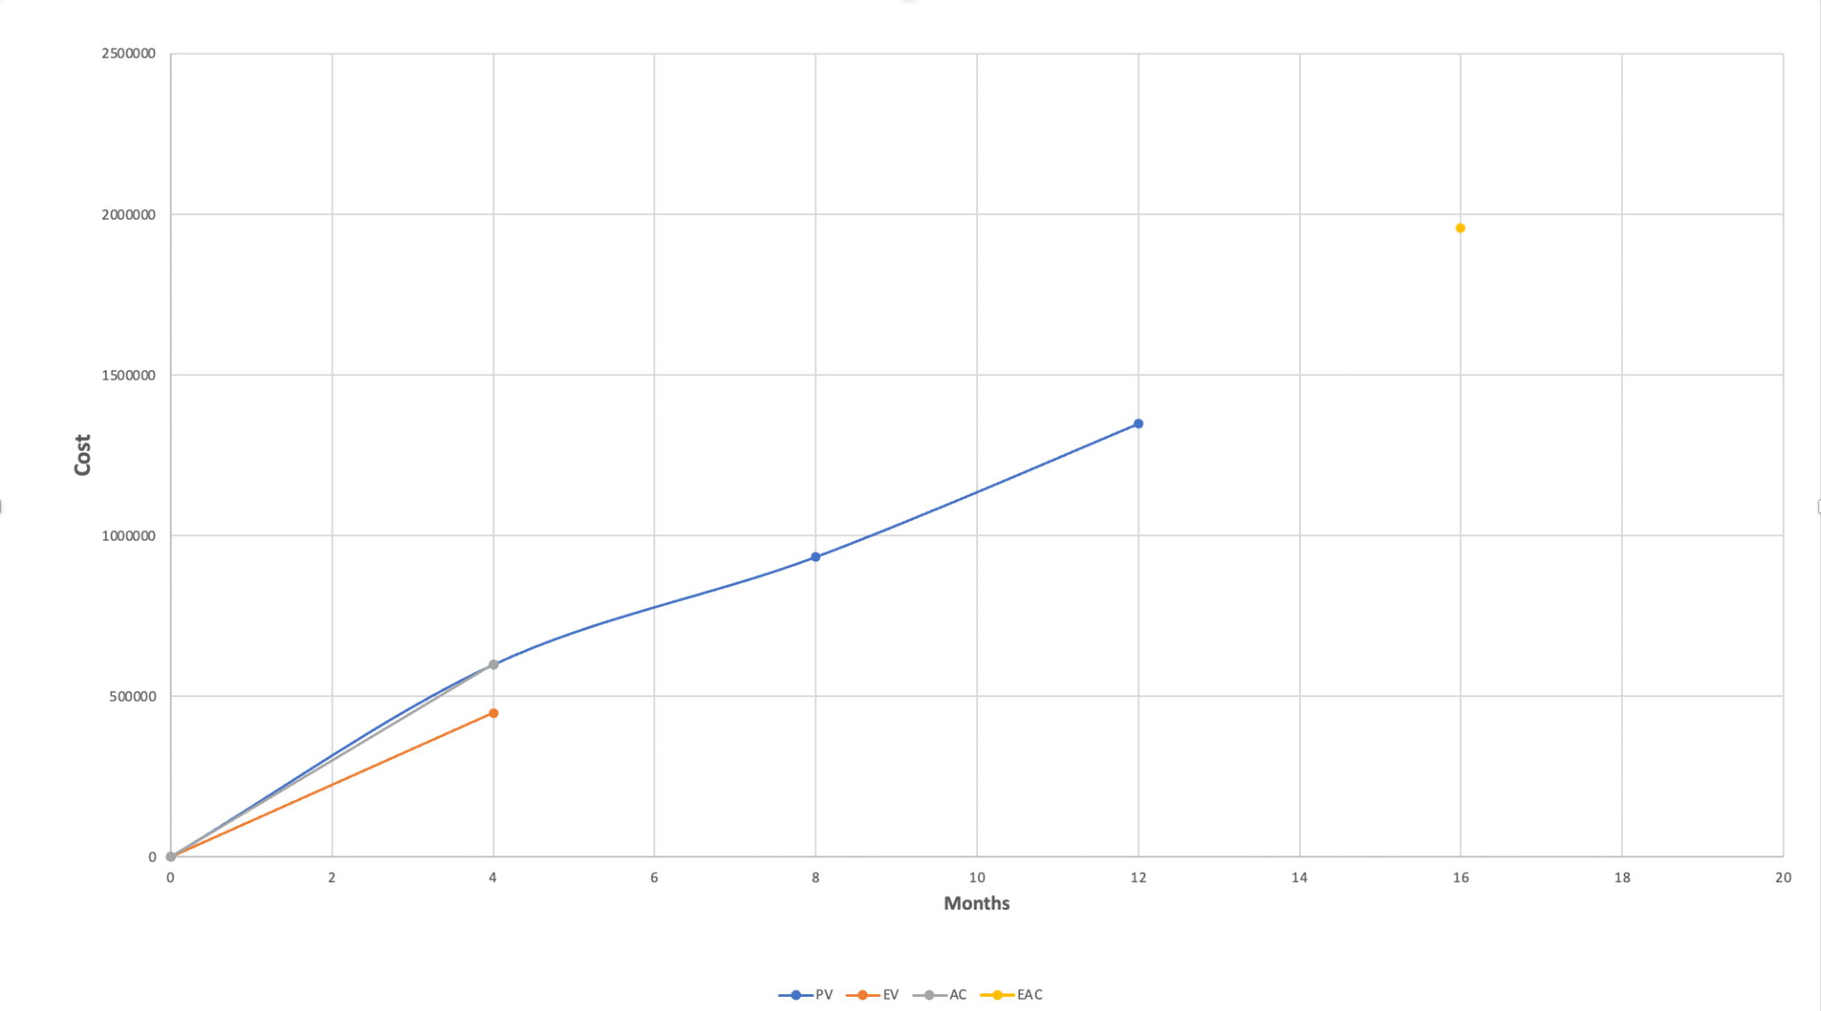

*Image 2: Earned Value Chart*

### MEMORANDUM

Date: 25 February 2022

TO: Top Management

FROM: AMC Consulting

SUBJECT: Project Status and recommendations

Progress:

About 25% of the work was completed in the 4-month which was unplanned. As for the first four months, the money spent is about $600,000 which is slightly over than the given budget. The cost management plan has been prepared. According to that and our current progress the project is projected to be completed in a 16-months period.

Causes

* It was too early to get an overview of the project before its execution.
* The schedule has been drastically changed from 3 years to a 12-month period which caused the sudden change in the dynamics of the workflow.

Recommendations:

* Hiring additional workers for the Networking Department.
* Asking workers to do over-time in the Networking departm

# Time Sheets:

| **Timesheet** |  |  |  |
| --- | --- | --- | --- |
|  |  |  |  |
| **Date submitted:** | 13th December 2021 |  |  |
| **Team:** | 201 |  |  |
| **Project team member:** | Neerav Mehta |  |  |
| **Tutor:** | Anthony Wong |  |  |
|  |  |  |  |
|  |  |  |  |
| **Date** | **Task description** | **Actual hours** | **Running total** |
| 11/11/21 | Meeting 1 | 3 | 3 |
| 17/11/21 | Meeting 2 | 3 | 6 |
| 18/11/21 | Working on Project Charter for Case Study 1 | 2 | 8 |
| 24/11/21 | Meeting 3 | 3 | 11 |
| 26/11/21 | Working on the corrections in project charter | 1 | 12 |
| 29/11/21 | Researching and studying for RTM | 5 | 17 |
| 30/11/21 | Working on RTM | 5 | 22 |
| 1/12/21 | Continued working on RTM | 3 | 25 |
| 1/12/21 | Meeting 4 | 3 | 28 |
| 2/12/21 | Researching on Task 3 | 5 | 33 |
| 3/12/21 | Working on Task 3 | 3 | 36 |
| 5/12/21 | Continued working on Task 3 | 5 | 41 |
| 8/12/21 | Meeting 5 | 3 | 44 |
| 9/12/21 | Researching for task 1 and 2 | 2 | 46 |
| 10/12/21 | Working on task 1 | 3 | 49 |
| 13/11/21 | Meeting 6 | 6 | 55 |

# 

| **Timesheet** |  |  |  |
| --- | --- | --- | --- |
|  |  |  |  |
| **Date submitted:** | 13/12/2021 |  |  |
| **Team:** | 201 |  |  |
| **Project team member:** | Timothy Correia-Paul |  |  |
| **Tutor:** | Anthony Wong |  |  |
|  |  |  |  |
|  |  |  |  |
| **Date** | **Task description** | **Actual hours** | **Running total** |
| 11/11 | Meeting 1 | 3 | 3 |
| 17/11 | Meeting 2 | 3 | 6 |
| 17/11 | Summary Task | 1 | 7 |
| 20/11 | NPV Draft | 2 | 9 |
| 20/11 | Weighted Scoring Model Draft | 2 | 11 |
| 22/11 | Business Case Draft | 2 | 13 |
| 24/11 | Meeting 3 | 3 | 16 |
| 24/11 | Project Scope Statement | 2 | 18 |
| 24/11 | Running Case 1 Draft Review | 1 | 19 |
| 1/12 | Meeting 4 | 3 | 22 |
| 1/12 | Running Case 2 tasks review | 3 | 25 |
| 3/12 | Work Breakdown Structure Draft | 5 | 30 |
| 3/12 | Task durations and dependencies draft | 2 | 32 |
| 8/12 | Meeting 5 | 3 | 35 |
| 8/12 | Work Breakdown structure draft review | 5 | 40 |
| 8/12 | Task durations and dependencies draft review | 1 | 41 |
| 10/12 | Cost model draft | 1 | 42 |
| 13/12 | Meeting 6 | 6 | 48 |
| 13/12 | Running Case 3 draft review | 4 | 52 |
| 13/12 | Submission report preparation | 2 | 54 |

# 

| **Timesheet** |  |  |  |
| --- | --- | --- | --- |
|  |  |  |  |
| **Date submitted:** | 13/12/21 |  |  |
| **Team:** | 201 |  |  |
| **Project team member:** | Laurence Andrews |  |  |
| **Tutor:** | Anthony Wong |  |  |
|  |  |  |  |
|  |  |  |  |
| **Date** | **Task description** | **Actual hours** | **Running total** |
| 11/11/21 | Meeting 1 | 3 | 3 |
| 17/11/21 | Case 1 task 1, 2 and 4. Completed project charter alone | 5 | 8 |
| 24/11/21 | Case 1 continuation with calculating NPV and weighted scores | 7 | 15 |
| 26/11/21 | Case 1 finalising weighted scores and tweaking figures | 4 | 19 |
| 28/11/21 | Case 2 task 2 assisting with matrix | 4 | 23 |
| 1/12/21 | Case 3 task 2 working on milestones | 5 | 28 |
| 4/12/21 | Case 3 task 2 working on Gant chart | 7 | 35 |
| 8/12/21 | Case 3 task 2 working on milestones and SMART criteria | 6 | 41 |
| 9/12/21 | Case 3 task 4 working on network diagram drafting and calculations | 5 | 46 |
| 13/12/21 | Finalising network diagram and compiling | 6 | 52 |

| **Timesheet** |  |  |  |
| --- | --- | --- | --- |
|  |  |  |  |
| **Date submitted:** | 12/13/2021 |  |  |
| **Team:** | 201 |  |  |
| **Project team member:** | **Rounak Agarwal** |  |  |
| **Tutor:** | Anthony Wong |  |  |
|  |  |  |  |
|  |  |  |  |
| **Date** | **Task description** | **Actual hours** | **Running total** |
| 11/11/2021 | Meeting 1 | 3 | 3 |
| 11/17/2021 | Meeting 2 | 3 | 10.5 |
| 11/12/2021 | New specialized physical campuses business strategies | 2 | 5 |
| 11/12/2021 | potential benefits for these specialized campuses | 1 | 6 |
| 11/15/2021 | Initial assessment of the value for the project | 0.5 | 6.5 |
| 11/16/2021 | Worked with Neerav on Project Charter | 1 | 7.5 |
| 11/24/2021 | Meeting 3 | 3 | 21 |
| 11/19/2021 | Did a quick review of RTM | 1 | 11.5 |
| 11/20/2021 | Shortlisted a list of possible RTM | 2.5 | 14 |
| 11/21/2021 | Mentioned each RTM in detail | 3 | 17 |
| 11/23/2021 | Divided it into their corresponding business requirement | 1 | 18 |
| 12/1/2021 | Meeting 4 | 3 | 28 |
| 11/27/2021 | Had a brief go through for the WBS and task 4 | 4 | 25 |
| 12/8/2021 | Meeting 5 | 3 | 40.5 |
| 12/8/2021 | Developed a cost model for the project | 3 | 31 |
| 12/10/2021 | Cost baseline allocation | 3 | 34 |
| 12/12/2021 | Calculation of CV,SPI,CPI,and SV | 1.5 | 35.5 |
| 12/13/2021 | Value chart | 2 | 37.5 |
| 12/13/2021 | Meeting 6 | 3 | 40.5 |

## 

## Appendix: Meeting Minutes

### Meeting 1: Introduction and Case Studies

Time: 7.45pm

Date: 11th November 2021

Location: Zoom

Attendance: Laurence, Timothy, Neerav

Absentee: Rounak

Topics:

* Introductions
* Assignment Specifications Overview
* Assignment Scheduling

Minutes:

* Discussed Assignment 1 and Case Study 1
* Assignment Schedule:
  + Case Study #1 meeting on Wednesday 2.30pm
  + Further weeks: We will complete each week’s case study immediately after our on-campus tutorial class on wednesday.
* Homework: Revise the weekly content by sunday, in time for our study session

### Meeting 2: Case Study 1

Time: 2.30pm

Date: 17th November 2021

Location: Zoom

Attendance: Laurence, Timothy, Neerav, Rounak

Absentee: None

Topics:

* Discussing the case study 1 in detail.
* Working on it together and assigning tasks afterwards

Minutes:

* Started working on Case Study 1, Did Task 1, together one project by each member
* Assigned the rest of the tasks:
  + Task 2: Tim and Lawrence
  + Task 3: Rounak
  + Task 4: Neerav
* Meeting again next week after the tutorial 2.30pm and discussing everybody’s task.

Homework: Revise the weekly content by sunday, in time for our study session

### Meeting 3: Case Study 2

Time: 2.30pm

Date: 24th November 2021

Location: Woodside

Attendance: Laurence, Timothy, Neerav, Rounak

Absentee:

Topics:

* Discussed case study 1
* Going through the case study 2
* Had a brief discussion about the Requirements traceability matrix.
* Divide the tasks for case study 2.

Minutes:

* Discussed Assignment 1 and Case Study 2
* Discussed a few requirements for the RTM.
* Meeting again next week after 2:30PM and discussing

### Meeting 4: Case Study 3

Time: 2 pm

Date: 1st December 2021

Location: Zoom

Attendance: Laurence, Timothy, Neerav, Rounak

Absentee:

Topics:

* Discuss case study 2.
* Overview of Case Study 3
* Discussion of progress on case studies 1 and 2
* Allocation of tasks for case study 3

Minutes:

* Discussed the new case study
* Case study 3 tasks:
  + Task 1: Tim
  + Task 2: Laurence
  + Task 3: Neerav
  + Task 4: Rounak
  + Complete the tasks by next week
  + Reach out to the group if you need help for your task

### Meeting 5: Case Study 4

Time: 2:00 pm

Date: 8th December 2021

Location: Zoom

Attendance: Laurence, Timothy, Neerav, Rounak

Absentee:

Topics:

* Case study 3 recap and review
* Case study 4 overview
* Case study 4 division of tasks and responsibilities

Minutes:

* Reviewed our work on task 3 and gave each other feedback
* Implemented advice given during tutorial
* Read through case study 4
* Reviewed case study 4 calculations

### Meeting 6: Submission Preparation

Time: 5:00pm

Date: 13th December 2021

Location: Zoom

Attendance: Laurence, Timothy, Neerav, Rounak

Absentee: None

Topics:

* Submitting Assignment
* Editing Final Draft

Minutes:

* Overview of Assignment
* Assignment submission:
  + Each work on finalising each of the tasks and preparing the report
  + Tim and Laurence: focus on case study 3
  + Neerav and Rounak: focus on case study 4
  + Finalise report together